3.86: a) b) 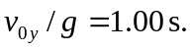 c) The speed relative to the man is 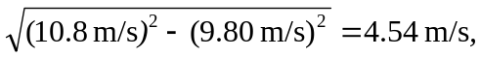 and the speed relative to the hoop is 13.6 m/s (rounding to three figures), and so the man must be 13.6 m in front of the hoop at release. d) Relative to the flat car, the ball is projected at an angle 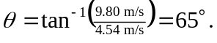 Relative to the ground the angle is 